**Using op-amps for amplification and filtering:**

7/2/2016 CE Lab – 3

**Discussed in this report:**

using LM1458 Dual operational amplifier in inverting and non-inverting amplifiers, low-pass Sallen-key filter, using frequency generator

LM1458 op-amps:

Op-amp stands for operational amplifiers, is a DC-coupled high-gain electronic voltage amplifier with a differential input and a single-ended output. An op-amp produces an output potential (relative to circuit ground) that is typically hundreds of thousands of times larger than the potential difference between its input terminals. The pin diagram for the LM1458 op-amp can be seen below.

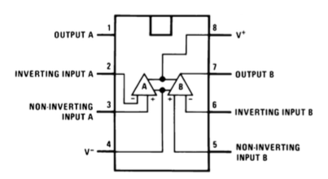

*(Image credit:* [*http://computersystemsartists.net/spring16/csc7011/assign/revolutionSensor/lm1458.pdf*](http://computersystemsartists.net/spring16/csc7011/assign/revolutionSensor/lm1458.pdf)*)*

These op-amps can be used to make inverting amplifiers and non-inverting amplifiers.

**Inverting amplifier:**

We can make an inverting amplifier using a 1458 op-amp like the figure below.

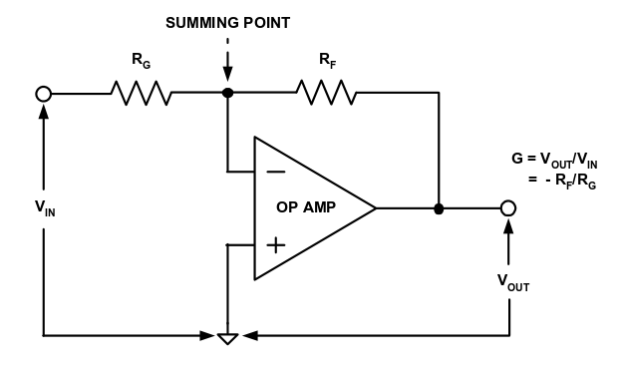

The power supply used is the +15V and -15V and can be adjusted to +12V and -12V.

The experiment tells us use resistors of moderately large resistance. We here use 10,000ohm and 1000ohm resistors.

Using the frequency generator for a sine wave of 1KHz on the oscilloscope we get

Vin = 2.32V

Vout=20.2V

Gain = Vout / Vin = 20.2/2.32 = 10

G = -Rf/Rg = 10000/1000 = 10

Channel one frequency = 998Hz , channel 2 pk-pk (voltage) = 12.1

Relative Phase of the waveforms: 170

**Non – inverting amplifier:**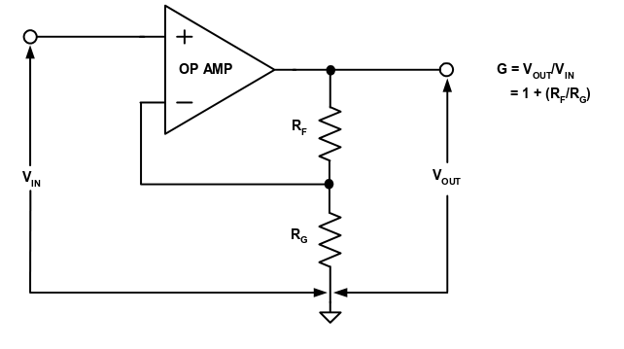

For non-inverting amplifier with a gain of 11, doing the same experiment.

Vout = 28.8V

Vin = 2.44V

Gain = Vout/Vin = 11.8

Gain = 1+Rf/Rg = 11

Channel one pk-pk (voltage) = 6.84

Channel two frequency = 984Hz , pk-pk (voltage) = 12.2V , Phase = 1.28

**Sallen Key low-pass filter:**

Second order low-pass filter design diagram -

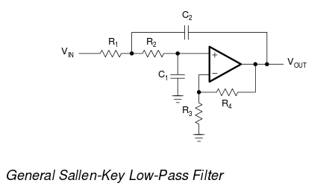

For R1 = 3.8K, R2 = 3.9K, C1= 22nF, C2 = 150nF and graphing the frequencies of 10Hz, 100Hz, 1000Hz, 10000Hz.

|  |  |  |
| --- | --- | --- |
| **Frequency** | **Vin** | **Vout** |
| **100** | **820mv** | **100mv** |
| **1000** | **800mv** | **100mv** |
| **10,000** | **780mv** | **60mv** |

**Gain = Vout/Vin**

1. Vout/Vin = 100/820 = 0.127
2. Vout/Vin = 100/800 = 0.125
3. Vout/Vin = 60/780 = 0.07

**Graphing this:**

